Team CoDDers

Table of Contents

Contents

Team 2

Stages 2

Coming up with an idea 2

Communication 2

Software we used 3

Completed Tasks 4

# Team

|  |  |  |  |  |
| --- | --- | --- | --- | --- |
|  | Emma Georgieva | Kristiqn Kostadinov | Valentin Pendashev | Sergei Alekseevich |
| Class | 10B | 10G | 10B | 10B |
| Role | Scrum Trainer | Backend Developer | Designer | Backend Developer |

# Stages

Creating a team

We found people who were willing to work with us and join our team.

1. Selecting a team
2. Distribution of our roles

# Coming up with an idea

1. Analyzed the potential of our team.
2. Distribute the tasks between our team members.

# Communication

For the communication we used Discord to arrange meetings and discuss our ideas. For sharing files, we used OneDrive and GitHub.

# Software we used



Microsoft Teams – communication

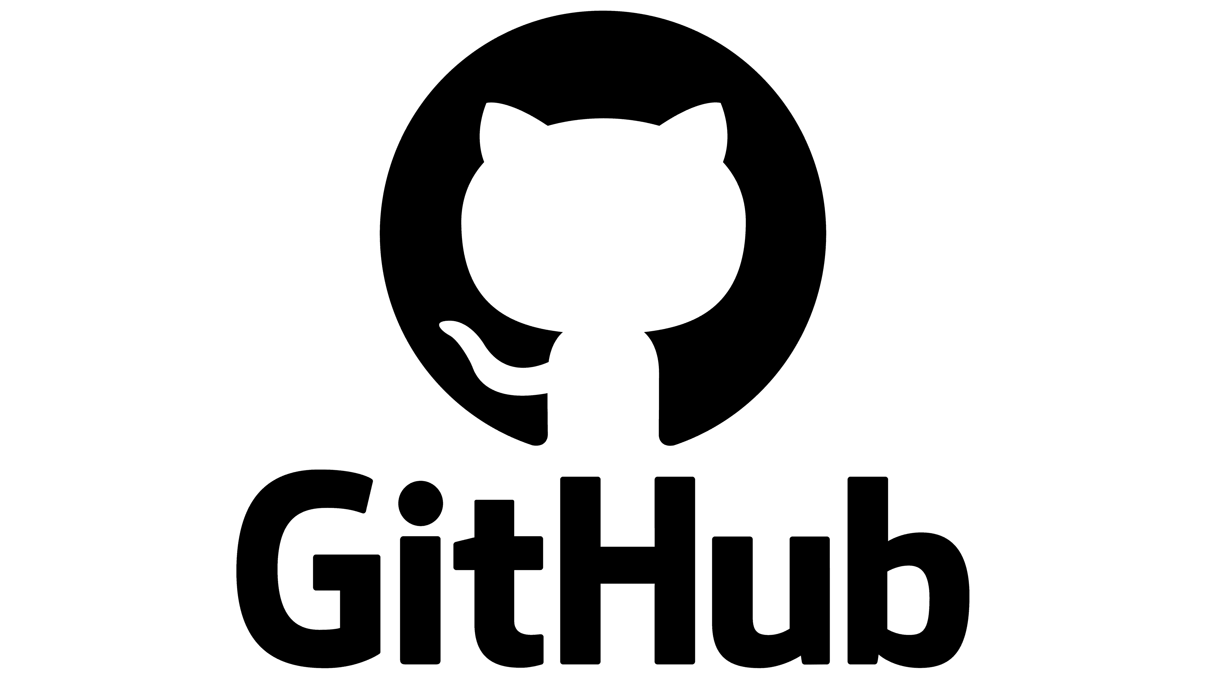

GitHub – sharing files



Microsoft Word – creating the documentation



Microsoft PowerPoint – creating the presentation

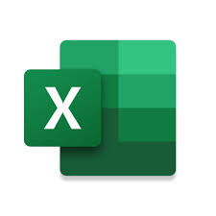

Microsoft Excel – creating the QA documentation



Visual Studio 2022 – writing the code

# Completed Tasks

|  |  |  |
| --- | --- | --- |
| № | Task | Status |
|  | Gather a team | ✓ |
|  | Distribute the roles | ✓ |
|  | Start writing the code | ✓ |
|  | Debug the game | ✓ |
|  | Start working on the documentation and presentation | ✓ |
|  | Make QA table | ✓ |
|  | Push all files to GitHub | ✓ |